Urban Search and Rescue Using Marsupial Robots

Abstract— a common distinction of marsupial mammals like a kangaroo is that the mother carries around the child in a pouch. Inspired by this concept from nature is the idea of marsupial robots. In this paper a larger multi-terrain "mother robot" and smaller versatile "baby robots" are designed. The mother robot would carry in its interior the baby robots through a treacherous and rugged terrain to a central rescue location, providing rapid, efficient and a sheltered transportation. The baby robots can then come out and start urban search and rescue by locating and helping people from a collapsed or damaged structure, where it is risky for humans or rescue dogs to go. Once the job of delivering the baby robots is complete, the mother robot acts as a "base station". It also has the task of transporting the baby robots back to safety once the mission is complete. In this paper we have designed the mother and baby robots which are suitable for urban search and rescue mission.
Keywords—marsupial robots; urban search and rescue; multi-terrain robot; mother robot; baby robots.

Introduction
Multi-robot system allows robots to divide and conquer the goal they are aiming to achieve. It also has other advantages like parallelism, dynamism, and provides better performance and adaptability than a single multi-tasking robot. Therefore in a search and rescue mission where the rescuers have approximately 48 hours to rescue their victim alive [1], multi-robot systems have raised a lot of interests [2, 3, 4]. One novel category of multi-robot system is known as the marsupial robots, inspired by the marsupial mammal, kangaroo. Here, a larger mother robot carries the smaller baby robots on its interior. The reason for using this concept for urban search and rescue is that a heterogeneous team of a large and many small robots can work together well as a team. The goal is to use the big and powerful mother robot's navigation strength to do the menacing work of carrying the babies to the central rescue zone across treacherous and rugged terrain, while allowing the more critical work of searching remote locations for survivors to smaller, specialized robots. Just like its biological counterpart, the mother robot can have a deeper connection with its babies than just being a transporter. It can also provide power, assistance and guidance [5].

Related Work
The mother robot of a marsupial robotic team, the Silver Bullet, a chassis of a children's jeep can hold one shape-shifting Bujold, the baby robot, in 'flat position' [5]. The Georgia Tech Yellow Jackets team in the AAAI 2002 Urban Search and Rescue (USAR) competition used both manually operated iRobot ATRV-Mini as the mother robot which could carry four Sony Aibos legged robots on an open platform in the back. They used a laser range scanner to map the disaster arena and Omni-directional camera as eye for the operator. The smaller legged Aibos with color video camera brought more versatility for mobility in the rescue arena [6]. Zhao designed a mother robot with two motors using a wheel-track combo for locomotion. It contains a dual-floor docking station with a lifting platform and camera. It has a dimension of 67cmx57cmx40cm [7]. Another team tested the miniature 200g Scout Robots, which is 11cm long and 4 cm in diameter. Although suitable for some situations, they were not quite successful in overcoming debris and holes and their low height meant poor camera angles [8]. But these types of robots are a good fit if many are deployed simultaneously. To assist fire fighters a 'system of systems' marsupial robots with a mother robot and three juvenile robots were assessed [9]. The 40kg Kohga3 robot is a rescue mini robot which was used to investigate collapsed buildings. This robot can climb over stars and angles up to 45 degrees [10, 11]. Another suitable rescue robot is the agile Quince, it has tracked wheels and is capable of driving over rubbles and climbing stairs [12]. In all of the above robot designs, the robots are either working alone or have a team which is not optimizing the marsupial mechanism.
In this paper a marsupial robotic team is designed. It constitutes of a bigger manual mother robot, which can hold a maximum of six autonomous baby robots at any given time. To our best knowledge our work presented in the paper is unique because we have designed a wheeled marsupial robotic system which is enhanced to work together with each other for search and rescue missions.
The remainder of the paper is presented as follows. In section III the system design of the mother and baby robots are described. Section IV shows the teamwork of the mother and baby robots. Cost analysis is in section V and section VI concludes the paper.

System Design
In the aftermath of a disaster like a building collapse, earthquake or tornado urban search and rescue becomes a task of extreme pressure. Not only the valuable time for rescuing the victims safely is very limited but the fragile rescue area is unsafe for both rescuers and victims. A group of lightweight suitable robots with good teamwork and mobility can go a long way to saving the lives of human beings.
The main design goals are to make the baby robot light weight so that it doesn’t damage the fragile and wrecked areas. It also has to be able to easily drive over small obstacles and uneven terrains. Good networks of range sensors are also required for avoiding big obstacles when traversing the arena. The mother robot has to be powerful with good navigation ability and big enough to be able to carry six baby robots. A camera has to provide a good viewing angle for the rescue team to be able to drive the robot effectively.

Baby Robots
The duty of the baby robot is to search and identify survivors across delicate zones and deliver them with small pack of food, simple tools for assistance, first aid and most importantly pass on the location of a survivor to rescuers via the mother robot.
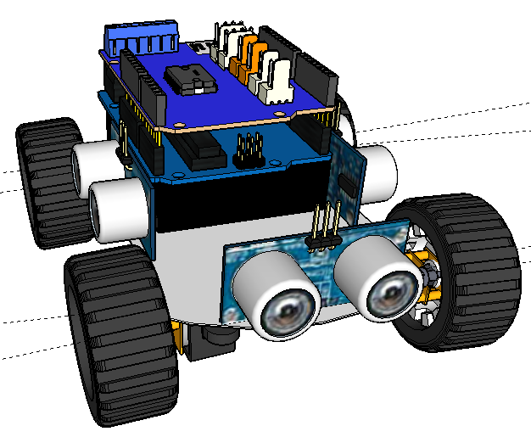

Figure 1: Isometric view of the baby robot

The key features of the baby robots are as follows:
• Structure of the robot: The baby robot is made using a PCB board. Since it has to travel over narrow fragile terrain, this robot is made very lightweight; about 500 g and it is also quiet small in size, 12cm x 12cm x 10cm.
• The Brain: The baby robot contains an ATmega328 based 16 MHz Arduino as its controller.
• Wheels and Motors: It contains four 600 rpm, 160 oz-in 6V DC micro metal gear motors. These motors are small light and consume low current. The 42mm diameter wheel has a 19mm rubber tire. The placement of the front wheels enables the robot to easily climb over any small objects. The motors are inverted and screwed at the bottom of the chassis, which gives the robot more clearance from the ground.
• External sensors: Three HC-SR04 sonar sensors give the robot vision and ability to smartly traverse the terrain.
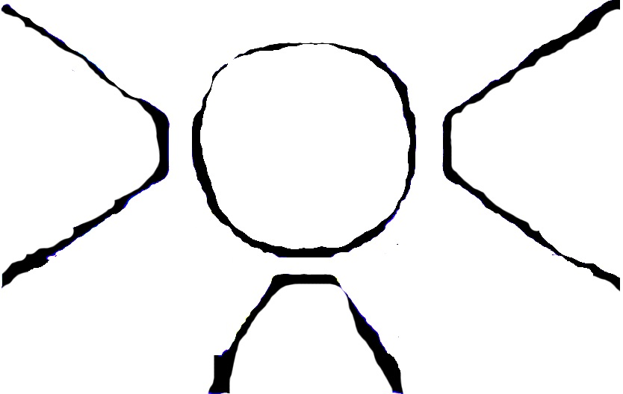
Figure 2: Range of the ultrasonic sensors.

Mother Robot
As just like in nature the mother is smarter, more powerful and bigger than its baby robots. The main supports the mother robot provides to its babies are as follows:
• Transporter: It carries the babies to and from a central search and rescue location
• Manager: The mother robot sets the formation for the baby robots, so as to prevent more than one robot to spend time searching in the same area.
• Messenger: If any survivor is found the message is sent to the mother robot. The mother computes the position of the survivor and forwards it to the rescuers.
The key features of the mother robot are as follows:
• Interior of the robot: The interior is divided into four chambers. The two side chambers are for the placement of the motor. The upper tier contains the controller, batteries and all other required components in the project. The bottom tier is the baby robot chamber. It has a very rough uneven floor with high friction to ensure that the baby robots don’t easily move out of place when the mother is traversing a rough terrain. It contains enough space for carrying six baby robots.
• Frame: The material of choice is steel because of its strength, toughness and weldability. It is therefore a suitable material for protecting the babies inside. However, steel is a conductor of electricity, so the circuit chamber has to be insulated using plastic for safety. It has a dimension of 40cm x 40cm x 12.5cm.
• The Brain: Since the mother robot has to carry out a lot of complex task, a microprocessor board, Raspberry Pi is chosen here.
• Wheels and Motors: Large 3.5' rubber wheels have been used in the robot to provide it with the ability to easily steer across and over multiple surfaces. High torque, high speed DC motors of car wipers are used.

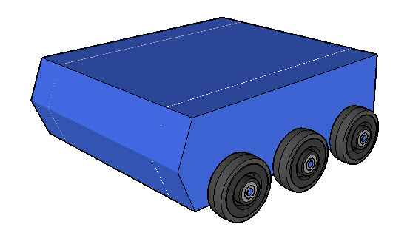
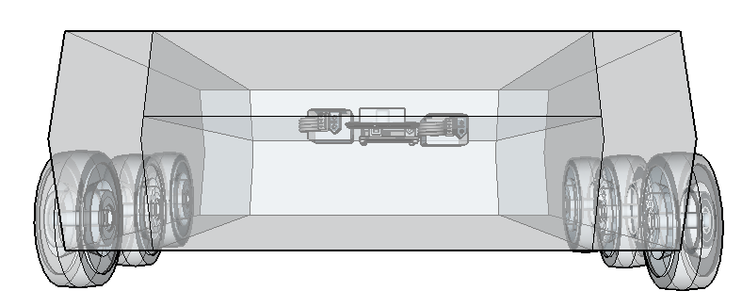
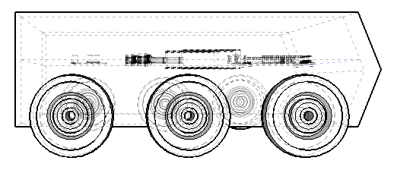
Figure 3: Isometric view and front view of the mother robot

Dockign Method of The Mother Robot
Once the mother robot goes close enough to a rescue site or if it gets stuck anywhere, it has to deploy the baby robots. The door at the rear end of the robot is flipped open using servo motors. It then makes an angle of about 25 degrees with the ground, which is within reach of the robot to travel across.
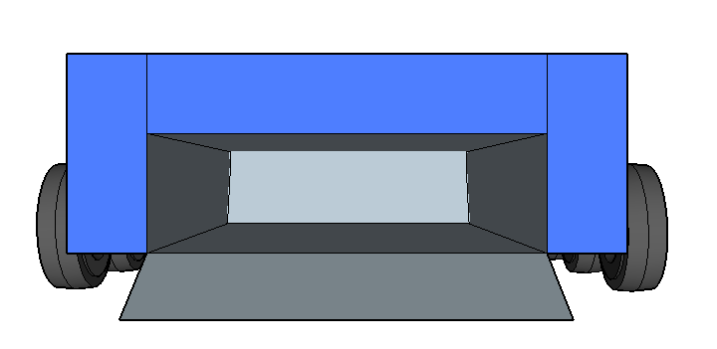
Figure 4: Docking mechanism of the mother robot

Team Work
Figure 7 shows the mother robot containing six baby robots inside. The baby robots are very compact so as to minimize any calamity when the mother is transporting them through bumpy and menacing routes. Once the mother reaches its central goal location, it stations itself. Then the door of the mother robot opens and the six robots slide out. Once the mission is over, the baby robots come back in and maintains the same orientation inside the congested baby chamber.

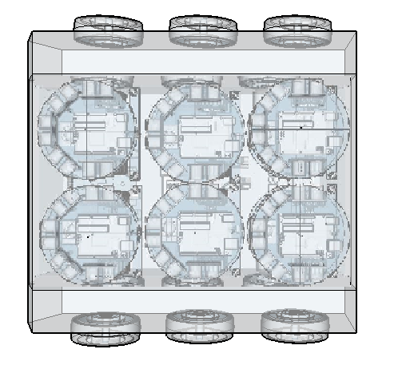

Figure 5: The baby robots placed inside the mother robot

Cost Analysis
Product Description | Quantity | Cost per Unit (TK) | Cost (TK)
Micro Metal Motor | 4 | 550 | 2200
Wheel Pair | 2 | 350 | 700
Motor Mount Pair | 2 | 380 | 760
Ultrasonic Sensor | 3 | 200 | 600
Arduino Uno | 1 | 850 | 850
Motor Driver Sheild | 1 | 800 | 800
PCB board | 1 | 150 | 150
Miscellaneous | - | 250 | 250
Total |  |  | 6310
As you can see the cost of the baby robot is very low compared to commercially available robots. Although limited in its capabilities, it is optimized for urban search and rescue operation.

Conclusion
This article focuses on the design a marsupial robotic system for urban search and rescue operation. The large powerful mother robot with good navigation prowess can transport six smaller baby robots on its interior. The manually controlled mother robot with a feedback camera transports the baby robots to the central rescue location. Its back door then tilts open and the six baby robots drive out of the mother robot. The baby robots are equipped with three simple sonar sensors to enable them to smartly traverse the arena. It is a light robot with good mobility and is easily able to traverse across uneven, rugged terrains.
Our future work will be on developing an algorithm for urban search and rescue operation.

References
[1] B. Shah, & H. Choset, Survey on Urban Search and Rescue Robotics.
[2] C. Lou, A. Espinosa, D. Pranantha and A. De Gloria, 'Multi-robot search and rescue team', in Safety, Security, and Rescue Robotics (SSRR), Kyoto, Japan, 2011, pp. 296 - 301.
[3] S. Grayson, 'Search & Rescue using Multi-Robot Systems', School of Computer Science and Informatics, University College Dublin
[4] C. Yue, G. Seet and S. Kok, 'Multiple-Robot Systems for USAR: Key Design Attributes and Deployment Issues', Int J Adv Robotic Sy, p. 1, 2011.
[5] R. R. Murphy, M. Ausmus, M. Bugajska, et al., "Marsupial-like mobile robot socities", Proceedings of 3rd International Conference on Autunomous Agents, pp. 364-365, 1999.
[6] F. Dellaert, T.R. Balch, M. Kaess, et al., "The Georgia Tech Yellow Jackets: A Marsupial Team for Urban Search and Rescue," AAAI Mobile Robot Competition, pp, 44-49, 2002.
[7] P. Zhao, Z. Cao, L. Xu, et al, 'The Design of a Mother Robot for Marsupial Robotic System', in International Conference on Mechatronics and Automation, Tianjin, China, 2014.
[8] P.E. Rybski, I. Burt, A. Drenner, et al., "Evaluation of the Scout Robot for Urban Search and Rescue", Center for Distributed Robotics Department of Computer Science and Engineering, University of Minnesota, 2003.
[9] T. Ngo, P. Hung and M. Pham, 'A Kangaroo inspired heterogeneous swarm of mobile robots with global network integrity for fast deployment and exploration in large scale structured environments', 2014 IEEE International Conference on Robotics and Biomimetics (ROBIO 2014), 2014.A System of System to Assist Fire Fighters
[10] E. Guizzo, 'Japan Earthquake: More Robots to the Rescue', Spectrum.ieee.org, 2015. [Online]. Available: http://spectrum.ieee.org/automaton/robotics/industrial-robots/japan-earthquake-more-robots-to-the-rescue. [Accessed: 28- Sep- 2015].
[11] S. Toto, 'After The Quake: Japanese Rescue Robot Scopes Out Damage In Collapsed Building (Video)', TechCrunch, 2015. [Online]. Available: http://techcrunch.com/2011/03/26/after-the-quake-japanese-rescue-robot-scopes-out-damage-in-collapsed-building-video/. [Accessed: 28- Sep- 2015].
[12] E. Guizzo, 'Japan Earthquake: Robots Help Search For Survivors', Spectrum.ieee.org, 2015. [Online]. Available: http://spectrum.ieee.org/automaton/robotics/industrial-robots/japan-earthquake-robots-help-search-for-survivors. [Accessed: 28- Sep- 2015].

